TWO DAY NATIONAL WORKSHOP ON GENDER SENSITIZATION

Organised by
Women’s Study Centre, UCW and Women Cell, UCW
in collaboration with IQAC, UCW
16- 17th February 2022
REPORT

The Inaugural Session for the Two Day National Workshop on Gender Sensitization began with inviting the Guests followed by lighting the lamp to invoke the God’s presence and a prayer song to mark the auspicious beginning of the program by the college choir. Dr. V. Srilatha, Director, Women’s Study Centre and Convener of the Workshop welcomed the guests and detailed about the significance of the workshop in the present scenario and the need to have to the participants. Dr. Loka Pavani, Coordinator, IQAC and Convener of the Workshop explained the significant role played by IQAC in achieving academic excellence and improvement of quality of Higher education leading to holistic development of the College. In her message, Prof. M. Vijjulatha, Principal, UCW have expressed concern that Gender Sensitization is the topic which many are not aware of, both men and women need to understand it. There is gender inequality in society wherein women are more oppressed and can be addressed through collective efforts of all sections of society.
Guest of Honour of the Workshop Prof. K. Laxmi, Former Principal, UCASS, Osmania University in her message have expressed that woman are more prone to various kinds of harassments, acid attack, female foeticide, etc which is making them more vulnerable economically, mentally and socially in the society. Women should be given equal opportunity to make choices regarding education, career, marriage and other important aspects of life thus aiming for a society with economic equality and equal partnership in decision making process. The Inaugural Session ended with a formal vote of thanks by Dr. G. Vijaya Lakshmi, Coordinator, Women Cell and Convener of the workshop.

Coordinator – Dr. K. S. N. Jyothi, I/c Head, Department of Genetics & Biotechnology, UCW
Speaker - Dr. N. V. Madhuri, Professor, Centre for Gender Studies and Development, National Institute of Rural Development, Hyderabad.
Dr. N. V. Madhuri madam began her lecture with explanation of stereotypical terms such as gender and sex. Her session was highly interactive where she made the participants speak about their views on gender equality. She gave the statistics of literacy and sex rtio in a realistic way and explained how over the generations there is a change in these statistics. Overall, keynote address by madam gave an insight into theme of the workshop.
Coordinator – Dr. P. Aruna, Department of History, UCW
Speaker – Prof. T. Mrunalini, Director, EMMRC, OU, Coordinator, School of Education, MHRD, Coordinator, IKS, Ministry of Education
By narrating various thought provoking stories, madam has stimulated the participants to introspect on gender related issues like gender equality and gender bias. She emphasized that thinking should try to overcome discrimination and change mind set, as we are still continuing with stereotypical roles. She further suggested that gender sensitization should begin from the school level to ensure equality.

Coordinator – Dr. M. Devendra, Department of Telugu, UCW
Speaker – Ms. V. Sandhya, President, Progressive Organisation for Women (POW)
Ms. V. Sandhya madam in her energetic and thought provoking message has discussed various types of harassments faced by women and girl students through various examples. Madam explained that through POW organisation, she has been fighting for various women related issues such as dowry deaths, equal wage for equal work, domestic violence, violence on women at work places, rights of children and women, empowerment of women, equal opportunities for women, emancipation of women and so on. She has also explained and shared her experiences regarding agitation movements conducted which led to promulgation of Domestic violence Act, Sexual Harassment at work places (prohibition) Act, 33% reservation for women, NRI dowry deaths, objectification of women in entertainment field, etc.

Day 2 Date: 17th February 2022, Thursday

Coordinator – Dr. K. Bala Ratna Kumari, I/c Head, Department of Economics, UCW
Speaker – Prof. G. B. Reddy, Director, University Foreign Relations Officer, Osmania University, Hyderabad
On the second day of Two National Workshop, Prof G. B. Reddy presented a lecture on Gender justice – Legal perspective. He focussed on the status of women by explaining the difference between sex and gender. Sir explained the position of women during ancient, vedic, medieval and British period. He also focussed on the position of women in developed countries and how they are discriminated in different ways. Sir threw light on various laws introduced in India like Hindu Widow Remarriage Act (1856), IPC Hindu Right to Properties Act (1937), etc. Sir also exemplified about the International Laws aimed to achieve gender equality, about recent judgement on third gender, transgender persons (protection of Rights) Act 2019, etc. By taking recent cases, he talked on sexual harassment of women at workplace both verbal and Non-verbal harassment. Sir concluded his lecture by taking the ongoing cases related to Gender justice and employment discrimination.
Coordinator - Dr. Vinita Panday, Department of Sociology, UCW
Speaker - Prof. Sheela Suryanarayanan, Associate Professor, Centre for Women’s Studies,
Hyderabad Central University.
Dr. Sheela Suryanarayanan focussed on new technologies which was contributing in sex determination of the foetus. While presenting her research work on patriarchal and matrilineal societies such as FGDs in Jaipur, Orissa and Meghalaya. She focussed on the notion of gender, son preference and daughter preference in Meghalaya. Through a highly interactive session, Madam has presented a framework highlighting the mindset, resources for changes to be brought and the changes per se which are required to inculcate gender equality and gender related issues.
Coordinator - Mrs. T. S. Savita, Department of Computer Science, UCW
Speaker – Mr. Rupesh, Founder & CEO, Cyber Jagruthi, Hyderabad
Mr Rupesh Mittal enlightened the audience with the importance of technology and how to be aware of different online frauds which the users encounter i.e., cyber crimes. Many case studies were discussed to spread the awareness of not becoming the cyber crime victim. He made clear how to protect our personal our personal data and demonstrated the procedure which each and every person who uses the online services needs to implement so that we do not become a cyber victim.
VALEDICTORY SESSION
The Valedictory session began with inviting the guests onto dais followed by the Report on the Two Day National Workshop presented by Dr. G. Vijaya Lakshmi, Convener. Later, Dr. V. Srilatha, Convener of the Workshop presented reflections on the workshop and focussed on the thrust issues discussed in the workshop, shared her experiences to indicate how women need the mindset of the society to be changed to face challenges of life. Guest of Honour Prof. Ghanta Chakrapani, Former TSPSC Chairman in his message expressed that we are living in male dominated society which has been created ages back and it is the family as a unit should instill the concepts of gender equality in young minds and should become part of life. Chief Guest Prof. D. Ravinder, Hon’able Vice-Chancellor, Osmania University in his valedictory message motivated the faculty to change the perception of gender to have harmonical society . He reiterated the role of higher education institutions and faculty has there is increasing enrolment of girls in higher education .The session ended with Vote of thanks proposed by Dr. Loka Pavani, convener of the workshop.

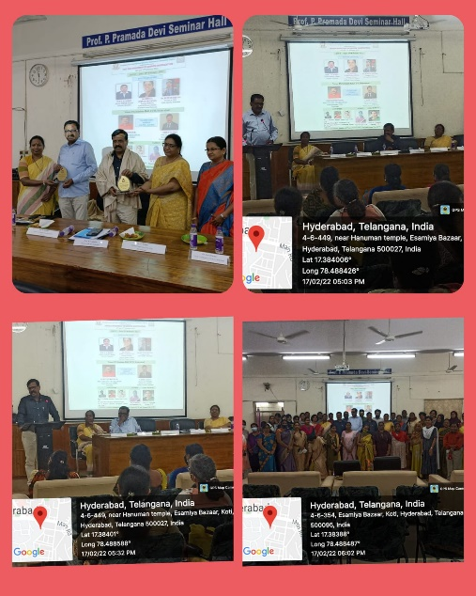
Photos
