Faculty Information
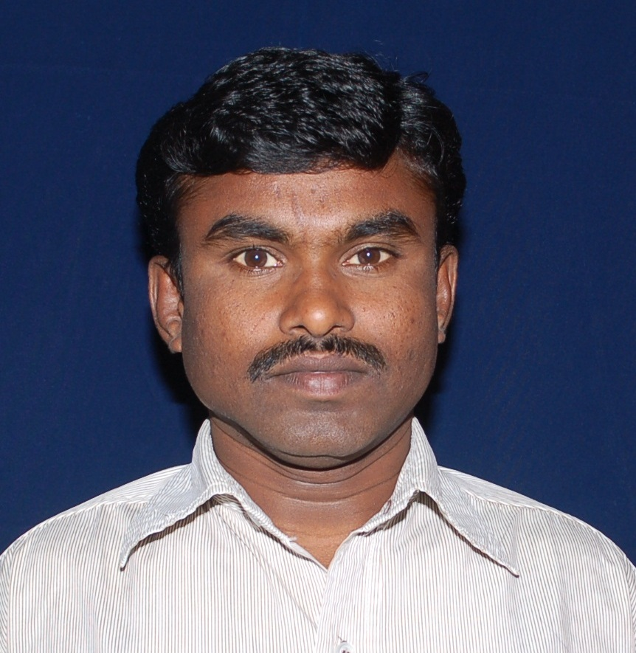
Detailed CV

- Personal Details
Name of the faculty | Dr.V.VENKATESH
Employee ID | 803011
Gender | Male
Department , College/University | Department of PHYSICS, University College for Women, Koti,  Osmania University
PAN | AGNPV6183G
Adhaar No. | 200682466318
Designation | Assistant Professor (Contract)
Qualification | M.Sc (Physics), Ph.D
Date of Joining  (Submit Appointment Letter) | 10th October, 2013
Date of Birth | 10th May, 1982
Category | S.C. (Madiga)
Mobile Number | 9603988284
E-Mail Id | venkateshv@osmania.ac.in
Address | Flat- No.F-307, VISTA HOMES, Kushaiguda, ECIL,  Hyderabad-500103, Telangana, India

- Academic details:
Degree | Qualification | Month and Year of Passing | Division | % of Marks | Univ/Board/  Institution with State
PG (M.A./M.Com/  M.Sc/M.Tech/  MBA/ MCA/Any other) | M.Sc (Physics) | May 2006 | First | 61.25 | Osmania University  Telangana
CSIR/UGC-NET  /SELT/Any other | GATE | 2007 | Score 225 |  | GATE 2007
Any other
Research details | Title of Thesis |  |  | Month and Year of award | Univ/Board/  Institution with State
Ph.D | Thermal and Electrical Properties of Co-Doped Ceria Based Materials for SOFC Applications |  |  | Dec 2013 | Osmania University  Telangana
Any other
*Please provide the scanned copies of certificates- Yes, Provided

- Teaching Experience: Total: ____15_ yrsUG: _15__yrs PG:__08_yrs

- Carrier Development Programs: Orientation Course/ Refresher courses/Short Term Course/Faculty Development Programme

Course attended | Institution /University | Title of the Professional Development Programme | Duration
 |  |  | From | To
Faculty Development Programm | Nizam College, Osmania University | Empowering Teachers in Teaching -Learning and Research | 6th Jan, 2020 | 11th Jan, 2020
Online FDP | Department of Physics  CBIT | Engineering Physics and Materials Science | 3rd Aug, 2020 | 7th Aug, 2020
* Please provide the certificatesYes, Provided

- Research Details:
Research Experience(No. of years): | 12
Area of research : | Material Science, SOFC materials
Supervisor for M.Phil/Ph.D  (GuideshipLetter) | NIL
No of students working/Registered | Ph.D: NIL

- Total No. of Research Publications: 07 International: 05 National:02
  - List of publications(## If possible use MS-Excel file which is attached as separate file):
Yes, provided as an attachment

SNo | Title of Paper | Name of the Authors | Name of the Journal | Volume and Page No | Month and Year of Publication | Peer reviewed/ Non Peer reviewed | Impact factor | National/ International | ISSN No. | UGC Journal No | Citation index (SCI.,/SCOPUS/Web of Science/ICI | No. of citation excluding self citation | h-index | Institutional affiliation as mentioned in publication
1 | Thermal and electrical properties of Ce0.8-x Pr x Sm0.2O2-δ electrolyte materials for IT-SOFC applications | Venkatesh V and C.Vishnuvardhan Reddy | Ionics | 23 and page 3455 | May 2017 | Peer Review | 2.27 | International | DOI 10.1007/s11581-017-2129-3 |  |  | 6 |  | Nizam College
* please provide the PDF or scanned copy of the articles along with ISSN no. and DOIYes Provided

SIGNATURE

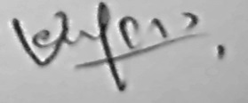

(DrVenkatesh V)

